INDUSTRY/ INTERNATIONAL HIGHER LEARNING

10215CS173- Large Language Models (LLMs): Fine-Tuning, RAG, and Agentic AI LLMs in Edge

AI CHATBOT USING NLP, RAG AND FINE-TUNING

final project report submitted in partial fulfillment for the award of the degree of

Bachelor of Technology in Computer Science and Engineering

Submitted By

B.DHARANESWAR REDDY (VTU28429)
YESHVANTH (28252)

Under the direction of
MURUGAVEL B B.E,M.Tech,MBA(PhD)
Reader in Intelligent Systems
School of Engineering
Chief Projects Officer
ATRIBS GLOBAL TECHNOLOGY
CHENNAI

Department of Computer Science and Engineering
School of Computing
VEL TECH RANGARAJAN DR.SAGUNTHALA R&D INSTITUTE OF SCIENCE

AND TECHNOLOGY
(Deemed to be University Estd.u/s 3 of UGC Act1956)
Accredited by NAAC with A++ Grade, Chennai-600 002
TAMIL NADU, INDIA
SEPTEMBER 2026
AI CHATBOT USING NLP, RAG AND FINE-TUNING
Technical Documentation

TABLE OF CONTENTS
1. Aim and Objectives
2. Introduction
3. State-of-the-Art Technologies
3.1 Hardware
3.2 Software
3.3 Applications
4. Research Gaps
5. Research Questions
6. Research and Development in AI Chatbots
7. Proposed Innovative Solution
7.1 Task 1 – Basic AI Chatbot
7.2 Task 2 – RAG-Based AI Chatbot
7.3 Task 3 – Fine-Tuned AI Chatbot
8. Impact Analysis
8.1 Technical Impact
8.2 Economic Impact
8.3 Social Impact
8.4 Environmental Impact
9. Cost Analysis
10. Commercialisation and Exploitation Plan
11. Conclusion
12. References

1. AIM AND OBJECTIVES

Aim
The aim of this project is to develop and progressively improve an AI-based chatbot through three different approaches: a basic NLP chatbot, a Retrieval-Augmented Generation (RAG) chatbot, and a fine-tuned language-model-based chatbot. The project demonstrates how a chatbot can evolve from predefined conversational responses into a system capable of retrieving relevant information and adapting a pretrained language model using a custom dataset.

Objectives
- To develop a basic conversational chatbot using Natural Language Processing techniques.
- To implement text similarity-based response selection using TF-IDF and cosine similarity.
- To enhance the chatbot using Retrieval-Augmented Generation.
- To retrieve relevant information from an external knowledge base.
- To generate responses using retrieved contextual information.
- To prepare a custom dataset for chatbot fine-tuning.
- To fine-tune a pretrained language model using the custom dataset.
- To compare the three chatbot development approaches.
- To understand the practical application of NLP, RAG, embeddings, vector search, and fine-tuning.

2. INTRODUCTION
Artificial Intelligence has significantly changed the way humans interact with computer systems. Chatbots are one of the common applications of Artificial Intelligence and Natural Language Processing, allowing users to communicate with software using natural language.
Traditional chatbots generally depend on predefined rules or manually created responses. Although such systems are simple to implement, they have limited conversational capabilities and may fail when users ask questions that were not included in the predefined knowledge base.
This project addresses this limitation by developing the chatbot in three progressive stages. The first stage implements a basic NLP chatbot using predefined intents, TF-IDF vectorization, and cosine similarity. The second stage introduces Retrieval-Augmented Generation (RAG), where relevant information is retrieved from a knowledge base and provided as context for response generation. The third stage uses a custom dataset to fine-tune a pretrained language model, allowing the model to adapt to the chatbot's specific conversational requirements.
The three tasks demonstrate different approaches to building intelligent conversational systems and provide practical understanding of how retrieval and model adaptation can improve chatbot capabilities.

3. STATE-OF-THE-ART TECHNOLOGIES

3.1 Hardware
The chatbot does not require specialized hardware for development or execution. The project can be developed using a standard computer or through cloud-based platforms such as Google Colab. The minimum requirements include a computer or laptop, at least 4 GB RAM, an internet connection, and a standard processor. A GPU is optional but can accelerate model training during the fine-tuning stage.

3.2 Software
The project uses Python and Google Colab as the primary development environment. The major libraries and technologies include NLTK, Scikit-learn, Pandas, Sentence Transformers, FAISS, Hugging Face Transformers, Hugging Face Datasets, PyTorch, and FLAN-T5.

3.3 Applications
- Customer support
- Education
- Healthcare assistance
- Banking and financial services
- Technical support
- Information retrieval
- E-commerce
- Cybersecurity assistance
- Virtual assistants
- Knowledge management

4. RESEARCH GAPS
Traditional rule-based and intent-based chatbots have several limitations. Their responses are generally restricted to the patterns and answers manually defined by the developer. A major limitation is the inability to provide information that is not present in the predefined knowledge base. Simple keyword or similarity-based approaches may also fail to capture the deeper semantic meaning of user queries.
RAG-based systems address part of this limitation by retrieving relevant external information before generating a response. However, response quality depends on the quality of the knowledge base and retrieval mechanism. Fine-tuning provides another approach by adapting a pretrained model to a particular dataset or task, but it requires suitable training data and computational resources. Therefore, this project explores these approaches progressively.

5. RESEARCH QUESTIONS
- How can a basic NLP chatbot respond to user queries using predefined conversational patterns?
- How can TF-IDF and cosine similarity be used to identify the most relevant chatbot response?
- How can Retrieval-Augmented Generation improve the chatbot's ability to answer knowledge-based questions?
- How can embeddings and vector similarity improve information retrieval?
- How can a pretrained language model be adapted using a custom chatbot dataset?
- What differences can be observed between a basic chatbot, a RAG chatbot, and a fine-tuned chatbot?

6. RESEARCH AND DEVELOPMENT IN AI CHATBOTS
The development of AI chatbots has progressed from rule-based systems to machine-learning-based conversational systems and modern generative AI. Early chatbots relied primarily on predefined rules and keyword matching. Later systems incorporated Natural Language Processing and machine learning to identify user intent and provide more appropriate responses.
Modern chatbot systems increasingly use transformer-based language models capable of understanding and generating natural language. RAG further extends these systems by allowing models to retrieve information from external sources before generating responses. Fine-tuning provides another method for adapting pretrained language models to specific tasks and domains.
This project demonstrates this progression through three practical implementations: a basic NLP chatbot, a RAG-based chatbot, and a fine-tuned language model.

7. PROPOSED INNOVATIVE SOLUTION
The proposed solution is a three-stage AI chatbot development system. Instead of implementing only one chatbot architecture, the project develops three progressively advanced versions.

7.1 Task 1 – Basic AI Chatbot
The first task implements a basic conversational chatbot using predefined intents and responses. The chatbot contains categories such as greetings, introduction, help, weather, jokes, emotions, and goodbye.
TF-IDF is used to convert predefined patterns into numerical vectors. When a user enters a message, the message is converted into a vector and compared with stored patterns using cosine similarity. The pattern with the highest similarity is selected, and the chatbot returns a response associated with the corresponding intent.
Working process: User Input → Text Preprocessing → TF-IDF Vectorization → Cosine Similarity → Best Matching Pattern → Intent Identification → Response.
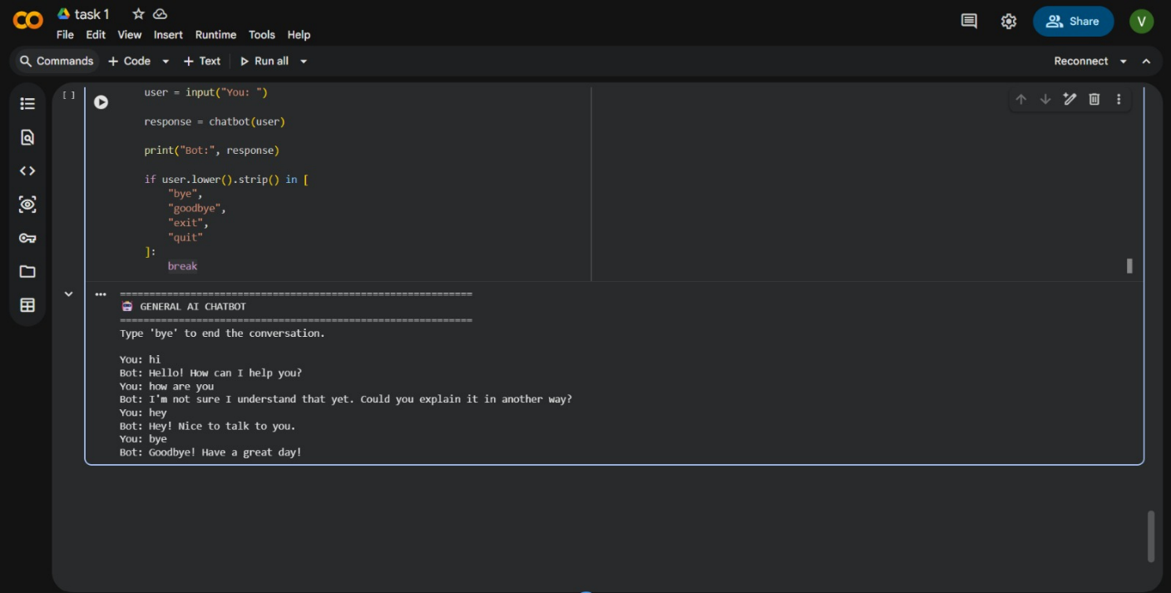
Result: The basic chatbot successfully performs simple conversations and responds to predefined types of questions. However, its knowledge is limited to the patterns and responses included in the program.

7.2 Task 2 – RAG-Based AI Chatbot
The second task enhances the chatbot by introducing Retrieval-Augmented Generation. RAG combines information retrieval with language generation. Instead of depending entirely on predefined responses, the system retrieves relevant information from a knowledge base and provides the retrieved information as context to the language model.
Text from the knowledge base is converted into embeddings using a sentence-transformer model. These embeddings are stored in a vector index using FAISS. When the user enters a question, the question is converted into an embedding and compared with the stored embeddings. The most relevant information is retrieved and passed to the generation model.
Working process: User Query → Query Embedding → FAISS Similarity Search → Relevant Information → Context + User Query → Language Model → Generated Response.
- Sentence Transformers
- Embeddings
- FAISS
- Transformer-based language model
- Python
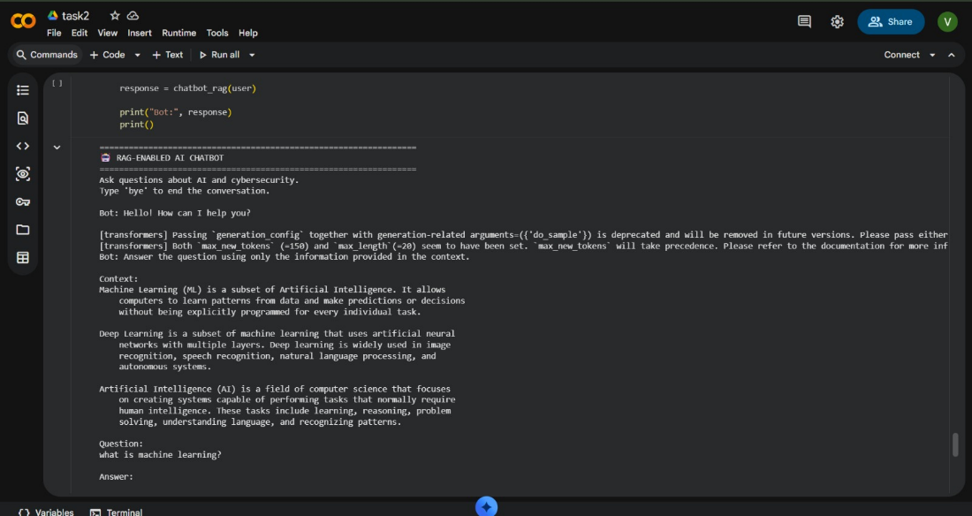
Result: The RAG-based chatbot can retrieve relevant information from its knowledge base before generating a response. This allows the system to answer questions based on information that is not directly stored as predefined chatbot responses.

7.3 Task 3 – Fine-Tuned AI Chatbot
The third task focuses on adapting a pretrained language model using a custom chatbot dataset. A dataset containing user inputs and expected responses is created. The dataset is loaded using Pandas and converted into a Hugging Face Dataset.
A pretrained FLAN-T5 model is then loaded. The input and response pairs are tokenized and provided to the model during training. The model parameters are adjusted using the custom dataset so that the model becomes better adapted to the conversational examples provided.
Working process: Custom Dataset → Data Cleaning → Tokenization → Pretrained FLAN-T5 → Fine-Tuning → Saved Model → Chatbot → Generated Response.
The dataset contains two main fields: input and response. For example, an input may be 'What is machine learning?' and the corresponding response may explain the concept of machine learning.
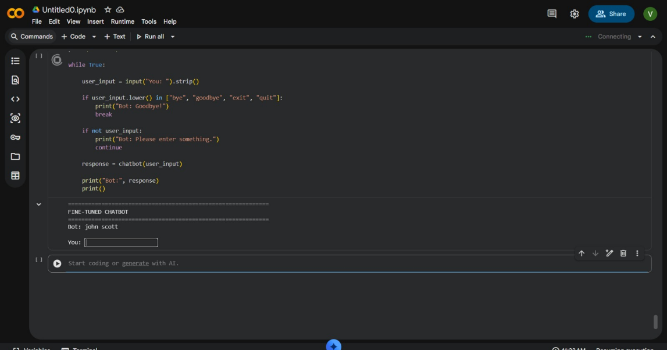
Result: The pretrained language model is fine-tuned using the custom chatbot dataset. The task demonstrates how pretrained language models can be adapted for specific conversational requirements.

8. IMPACT ANALYSIS

8.1 Technical Impact
The project demonstrates the practical integration of Natural Language Processing, text vectorization, semantic embeddings, vector similarity search, Retrieval-Augmented Generation, transformer models, dataset preparation, and model fine-tuning. The modular structure allows individual components to be replaced or improved.

8.2 Economic Impact
The chatbot can reduce the need for repetitive manual responses in applications such as customer support and information services. Using open-source libraries and pretrained models can reduce development costs during prototyping.

8.3 Social Impact
AI chatbots can provide users with quick access to information and basic assistance. They can be used in education, technical support, customer service, and information systems. Appropriate validation is required when chatbots are used in sensitive or high-impact domains.

8.4 Environmental Impact
The project can be developed using cloud-based computing resources and open-source models, reducing the need for dedicated hardware during development. Smaller models can reduce computational requirements for educational and prototype applications.

9. COST ANALYSIS
Component | Estimated Cost
Python | Free
Google Colab | Free tier available
NLTK | Free
Scikit-learn | Free
Hugging Face Transformers | Free / Open Source
Hugging Face Datasets | Free / Open Source
FAISS | Free / Open Source
Sentence Transformers | Free / Open Source
PyTorch | Free / Open Source
Development Hardware | Existing computer/laptop
Total Prototype Cost | Minimal
The actual cost may increase if paid cloud GPU resources or commercial AI APIs are used for larger-scale deployment.

10. COMMERCIALISATION AND EXPLOITATION PLAN
The proposed chatbot architecture can be adapted for different application domains. Potential applications include educational assistants, customer support systems, internal company knowledge assistants, technical support chatbots, e-commerce assistants, enterprise information systems, and domain-specific virtual assistants.
The RAG architecture can be extended to support company documents, manuals, FAQs, policies, and other organizational knowledge sources. The fine-tuning approach can also be used to adapt language models for specialized conversational tasks.

11. CONCLUSION
This project demonstrates the progressive development of an AI chatbot through three different approaches. Task 1 implemented a basic NLP chatbot using predefined intents, TF-IDF, and cosine similarity. Task 2 introduced Retrieval-Augmented Generation, allowing the chatbot to retrieve relevant information from an external knowledge base before generating responses. Task 3 focused on fine-tuning a pretrained FLAN-T5 language model using a custom chatbot dataset.
Overall, the project provides practical exposure to NLP, information retrieval, embeddings, vector databases, RAG, transformer models, and fine-tuning. The three-stage approach demonstrates the progression from a simple similarity-based chatbot toward more advanced AI-powered conversational systems.

12. REFERENCES
1. Google Research – FLAN-T5: Instruction-Finetuned Text-to-Text Transformer.
2. Hugging Face Transformers Documentation.
3. Hugging Face Datasets Documentation.
4. Scikit-learn Documentation – TF-IDF Vectorization and Cosine Similarity.
5. NLTK Documentation – Natural Language Toolkit.
6. Sentence Transformers Documentation.
7. FAISS – Facebook AI Similarity Search Documentation.
8. PyTorch Documentation.
9. Lewis et al., Retrieval-Augmented Generation for Knowledge-Intensive NLP Tasks.
10. Vaswani et al., Attention Is All You Need.\
11. GITHUB LINK: https://github.com/yaminidhalavayi/ihl-code

